

**This week in:**

**Mrs. Hodys’ Class**

[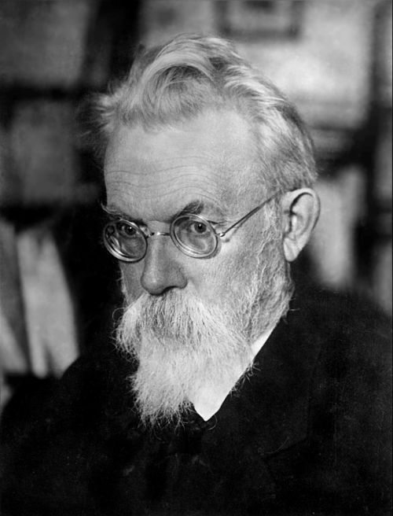](https://en.wikipedia.org/wiki/File:1934-V_I_Vernadsky.jpg)****

**Math:**

Continuing our skill of fractions, students will be able to subtract fractions by renaming, identify patterns in a sequence, and practicing fractions in word problems. We will be covering lessons 6.7-6.10 this week. Students will have a summative over 6.7-6.10 TBD

**Science:**

We are beginning a new unit “Matter is Everywhere.” What is matter? Does it exist if we cannot see it? What is the density of an object? What makes an object soluble? These are just some of the questions students will be able to answer by the end of this unit.

**\*\*Please note any time there is a summative, materials should still be coming home to study. (Both math and science)**

Important Reminders

* Feb 18th – NO SCHOOL – President’s Day
* Feb 20th – PBIS Popcorn
* Feb 21st – SCO Fun Night 4-6p
* Feb 22nd – Erin’s Law and SCO Hot Lunch

#ONEWALKER

Week of Feb. 18th – Feb 22nd

Jhodys@Summithill.org

[This Photo](http://8bchangemaker2010.wikispaces.com/Martin+Luther+King) by Unknown Author is licensed under [CC BY-SA](https://creativecommons.org/licenses/by-sa/3.0/)

Scientist of the Month

Steven Chu

(1948 - Present)

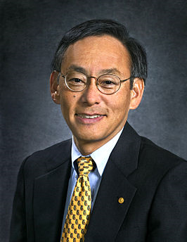

**Known For:** Force, Motion, Energy

**Studied:** Physics

A physicist is a scientist who studies force, motion, and energy. Mr. Chu received one of the top awards in science, the Nobel Prize, for successfully cooling and trapping atoms with lasers so they could be studied more accurately.

See more about Clyde Wahrhaftig on our Scientist Around the World Wall.