

**This week in:**

**Mrs. Hodys’ Class**

[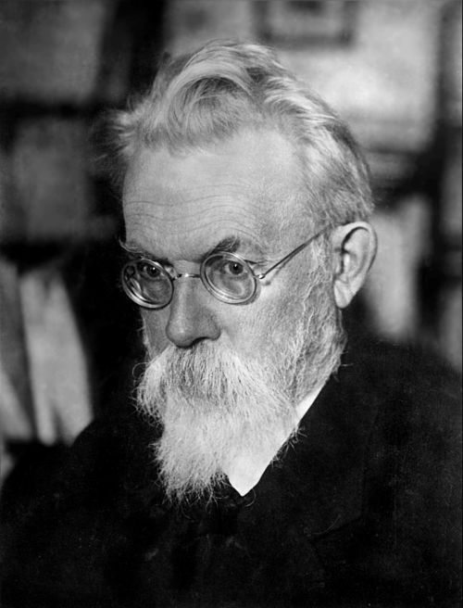](https://en.wikipedia.org/wiki/File:1934-V_I_Vernadsky.jpg)****

**Math:**

Students will continue to create ordered pairs and look at data in an input output table. Students will identify patterns in a data set to complete missing data. Word problems will be explored to practice understanding of patterns and relationships. Students will then complete tables with patterns and create line graphs.

**Science:**

Students are going to use their understanding of a solid, liquid, and a gas to determine when/if solutions create new substances and mixtures. Students will complete a lab to show a chemical change has occurred using vinegar and a penny. Students will be able to identify when a chemical change or a physical change has occurred and describe both changes.

**\*\*Please note any time there is a summative, materials should still be coming home to study. (Both math and science)**

Important Reminders

April 22nd – No School

April 24th – SCO Fun Night

April 25th – Talent Show Tryouts (Classroom)

#ONEWALKER

Week of April 21st – April 25th

Jhodys@Summithill.org

[This Photo](http://8bchangemaker2010.wikispaces.com/Martin+Luther+King) by Unknown Author is licensed under [CC BY-SA](https://creativecommons.org/licenses/by-sa/3.0/)

Scientist of the Month

Robert Goddard

(1882-1945)

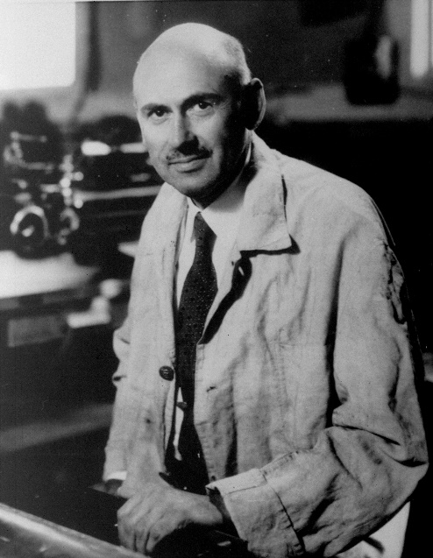

**Known For:** Rocket Scientist

**Studied:** Chemistry

Robert H. Goddard invented the liquid rocket fuel that helped United States astronauts travel into space.

See more about Robert Goddard on our Scientist Around the World Wall.