[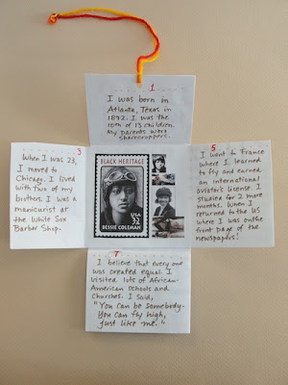](http://4.bp.blogspot.com/-83lkKHGAv-w/T2nUOzxZ1-I/AAAAAAAADmA/E2KtHEDRyvY/s1600/who%2Bam%2Bi%2B1.jpg)