Hi Parents,

Welcome to Rogus for the 2018-2019 school year! I will be your child’s Resource teacher and case manager at Dr. Julian Rogus Elementary School. This is my 18th year at Summit Hill School District. I taught at Indian Trail for my first five years and this will be my 13th year at Rogus. I have experience teaching General Education (Grade 3), Resource (Grades K-4), S.I.: Specialized Instruction (Grades K-4), T.I.P: Targeted Instructional Program (Grades 1-3), and Extended School Year (Reading Program- incoming Grades 2-5). I absolutely love my job and am thankful to be given the opportunity to work with your child this year .

IEP Meetings:
The school Special Education Team will meet early in the school year to set up IEP meetings (including Annual Reviews, Domain Conferences, and Re-evaluations). I will contact you for scheduling those dates and times. Thank you in advance for making arrangements to attend these meetings.

IEP Goal Updates:
I will send home your child’s updated IEP goals and objectives at the end of each quarter (at the time of report cards). The packet will include all IEP goals and objectives, including Resource (academics/ functional) and related services (Speech/Language, Social Work, and Occupational Therapy). Each service provider will update their own goals and objectives. If you have specific questions related to a certain area, please contact that person. Additional information that may be sent home with this packet may include reports and/or other updated data.

Blue Folder:
Your child will be given a blue Resource folder. We will use this is a means for home/school communication. It will include work that your child completed in Resource, extra practice activities, and communication. Please note that any activities that I provide are not graded. They will be a reflection of interventions and/or goals that we are working on in Resource. Your child may complete class work or tests with me. Since that is provided by the classroom teacher, that work may be graded by your child’s classroom teacher and sent home by that teacher.

Monthly Newsletter:
I will send home a monthly newsletter with current information. Please look for the “Resource Reader”. It will also be posted on my teacher page under “Downloads”.

Attachments:
Please fill out the attached Student Information Sheet and return to me (Mrs. Mecher, Room 195) as soon as possible. Please refer to the Abbreviations form as needed.

Contact Information:
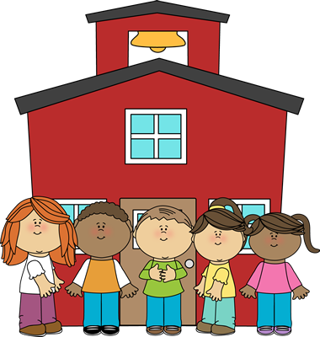
Please feel free to contact me at any time:
- Rogus Phone Number: (815) 464-2034
- School E-mail: kmecher@summithill.org
- Mrs. Mecher’s Web Page (for Downloads, Cool Links, etc.):
1. Go to www.summithill.org
2. Go to “Dr. Julian Rogus”
3. Go to “Teacher Pages”
4. Go to “Mrs. Mecher”

I am looking forward to a wonderful school year!

Thank you,
Mrs. Katie Mecher

2018-2019 Student Information for Mrs. Mecher

Child’s Name: __________________________________________ Prefers to be called: __________________________________

Date of Birth: _________________________________________ Age: _________________________________________________

Home Address: _______________________________________________________________________________________________________

Mom’s Name: ____________________________________ Mom’s Preferred Phone #: _____________________________________

Dad’s Name: _____________________________________ Dad’s Preferred Phone #: ______________________________________

Mom’s E-mail: ____________________________________ Dad’s E-mail: _________________________________________________

Do you need a second set of information mailed home to a parent not living with child? Yes/ No
If yes, please provide the following information:

Name: _______________________________________________________________________________________________________________

Address: _____________________________________________________________________________________________________________

Siblings (include names & ages): ________________________________________________________________________________________

Friends: ______________________________________________________________________________________________________________

Allergies: _____________________________________________________________________________________________________________

Medications: _________________________________________________________________________________________________________

Other health information: ____________________________________________________________________________________________

Interests/ Outside Activities: _________________________________________________________________________________________

Strengths: ___________________________________________________________________________________________________________

Areas of Need: _______________________________________________________________________________________________________

Home Behavior Reinforcement: _______________________________________________________________________________________

Student Motivators: _________________________________________________________________________________________________

Attended Extended School Year (ESY): Circle: Yes or No Attended Summer Tutoring: Circle: Yes or No

Additional Information you’d like to share: _____________________________________________________________________________

________________________________________________________________________________________________________________________

________________________________________________________________________________________________________________________

________________________________________________________________________________________________________________________

Thank you,
Mrs. Mecher, Room 195
Hi Parents,

Here’s a little cheat sheet explaining some abbreviations that I may write on your child’s work.
Thank you,
Mrs. Mecher

Abbreviation | Meaning
FS | Full Support: Student completed with teacher with prompting and help. Student was not able to complete independently.
PS | Partial Support: Student completed with some help/ prompting from teacher. Student could do parts independently.
I | Independent: Student completed on their own without help.
T | Together: Student and teacher completed together in class.
CW | Class work: Work student did in school.
HW | Homework: Work that is to be completed at home.

