Mrs. Mecher’s Resource Reader
~October 2018~

Students Need a Break
Students work hard to be respectful, responsible, and safe every day. Children benefit from movement throughout their day, both at school and at home. Here are two quick breaks that can be utilized if: 1. they need are feeling tired and need to wake up or 2. if they are feeling too excited and need to calm down. These can be utilized both at home and at school.
Wake Up Break  - 25 Jumping Jacks  - Jog in place for 15 seconds  - 5 Spring Jumps  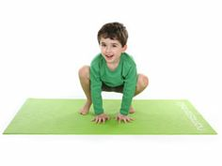  - Hook Up | Calm Down Break  - 20 Rocking Stars  - 5 Chair Push-ups  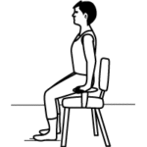  - 2 Melting Ice Cubes  - Hook Up

Communication:
- Blue Folder: Please keep your child’s blue resource folder in their backpack. Please use this is another means of home/ school communication.
- A Peek at My Week: Please review this weekly, sign, and return to me.

Practice Ideas for Home:
- Check my Teacher Page for websites and home practice ideas.
- Read or listen to story 20 minutes every night (stories from class, library books, books from home, on-line stories, non-fiction selections- such as magazines).
- Writing Practice: Spelling Words and Sentences; Journal Writing
- Fundations Home Support Packets (if applicable for your child)
- Sight Word Practice (reading, spelling, and writing)
- Math: basic facts; problem solving; time; money
- If you are interested, I’m more than happy to assist you with additional practice ideas specific to your child.
- Websites: X-tra Math, Prodigy, Turtle Diaries, Starfall, abcya.com

Web Page:
1. Go to www.summithill.org
2. Go to “Dr. Julian Rogus”
3. Go to “Teacher Pages”
4. Go to “Mrs. Mecher”

Contact Information:
- E-mail (best way to reach me): kmecher@summithill.org
- School Phone: 815-464-2034

Thank you for all you do for your child. Please know that I am here to help your child and support you with any questions, comments, or concerns.

Thank you,
Mrs. Katie Mecher

