Mrs. Mecher’s Resource Reader
~November 2018~
Parent-Teacher Conferences:
I look forward to meeting with many of you on November 19-20 for Parent-Teacher Conferences. If you scheduled a conference with your child’s homeroom teacher, I plan on attending. If you planned a separate conference with me, I’ll see you at your scheduled time in my room (195). Thank you

Quarter 1 Goal Updates:
With your child’s report card, you will receive updated goals/ objectives for all Special Education staff working with your child. You will also receive NWEA data from me if your child is being progress monitored in Reading and/or Math. Those scores are in italics on the right. Accommodations were in place for NWEA. Please let me know if you have any questions regarding NWEA. The next benchmark will be in December.

Executive Functioning:
Please read attached article for some tips to help your child manage difficulties with their Executive Functioning.

Communication:
- Blue Folder: Please keep your child’s blue resource folder in their backpack. Please use this is another means of home/ school communication.
- A Peek at My Week: Please review this weekly, sign, and return to me.
- E-mail (best way to reach me): kmecher@summithill.org
- School Phone: 815-464-2034

Practice Ideas for Home:
- Check my Teacher Page for websites and home practice ideas.
- Read or listen to story 20 minutes every night (stories from class, library books, books from home, on-line stories, non-fiction selections- such as magazines).
- Writing Practice: Spelling Words and Sentences; Journal Writing
- Fundations Home Support Packets (if applicable for your child)
- Sight Word Practice (reading, spelling, and writing)
- Math: basic facts; problem solving; time; money
- If you are interested, I’m more than happy to assist you with additional practice ideas specific to your child.
- Websites: X-tra Math, Prodigy, Turtle Diaries, Starfall, abcya.com

Web Page:
1. Go to www.summithill.org
2. Go to “Dr. Julian Rogus”
3. Go to “Teacher Pages”
4. Go to “Mrs. Mecher”

Thank you for all you do for your child. Please know that I am here to help your child and support you with any questions, comments, or concerns.

Thank you,
Mrs. Katie Mecher

-------------------------------------------------------------------------------------
Executive Functioning: Home Help

Mrs. Mecher, Resource Teacher at Dr. Julian Rogus Elementary School in Frankfort, attended a workshop, “Strengthening Your Special Needs Students’ EXECUTIVE FUNCTIONING SKILLS: Strategies for Organizing Tasks, Time, Materials, and Behavior” in Oak Lawn on October 24, 2018. There were many practical strategies, websites, and apps that were shared for educators working with students who may need extra support in these areas. The main areas that were covered included: Attention and Concentration, Organization, Time Management, Memory, Self-Regulation and Impulse Control, Flexible Thinking, and Emotional Control.

Students who have difficulties with Executive Functioning may exhibit some of these behaviors:
- Initiating tasks
- Keeping track of belongings
- Managing time
- Multi-tasking
- Asking for help
- Organizing belongings
- Retaining information
- Taking turns
- Waiting patiently

To help students at home, parents can try some of these strategies:
- Using a work completion checklist.
- Setting up and sticking with routines.
- Using timers or a countdown for task completion.
- Creating a morning list of what is needed for school. Creating an evening list of what is needed to do when student is home from school.
- Utilize a quiet study environment.
- Use quiet music if your child likes background music. Use upbeat music for transitions (“By the time this song is over, you need to have on your coat, shoes, and backpack.”)
- Have a designated area for important papers and homework supplies.
- Consider using an accordion folder for long-term projects. Tape calendar of due dates on the front. Label each section, such as: notes, graphic organizer, rough draft, final copy, research.
- Use sticky notes for bookmarks. They will stay in place better than a traditional bookmark. Use for stories, assignment notebook, etc.
- Use a Daily Homework Plan (see below)

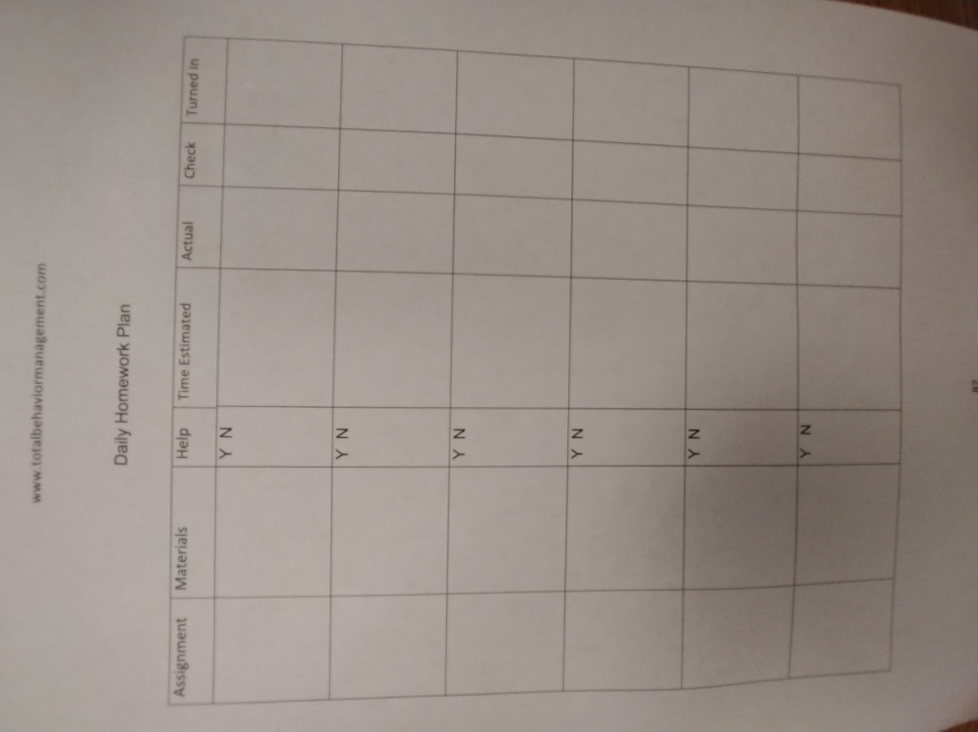
(Daily Homework Plan from www.totalbehaviormanagement.com)

