Battleship Game

- Print off 2 of each of the Battleship pages 1 and 2.
- On the first page that says, “Me” at the top, you will draw 4 ships. Each box on the grid equals 1cm. In order to draw a ship that measures 3cm you will draw one line that goes across 3 boxes. That ship will have 4 points to it. You will then draw a ship that measures 4cm. That ship will have 5 points to it. You may draw your ships horizontally, vertically, or diagonally anywhere on the grid. (See the bottom of the page for example.) Your partner will do the same on his or her sheet. You don’t want your partner to see where you are putting your ships. Once you and your partner have drawn in your ships it’s now time to play the game.
- To play the game you will call out a coordinate pair. Along the X axis you will see numbers 0-22. On the Y axis you will see the letters A-P. Your pair will consist of a number and a letter. Remember the X axis always comes first, so you will call out a number then a letter. Your partner looks on their sheet to see if you hit one of their ships or if you missed. On the second sheet you printed, you will keep track of what you called out. Don’t worry about keeping track of what your partner called out. Now it is your partner’s turn to call out a pair and try to sink one of your ships. Keep going back and forth until either one of you sinks all of his or her partner’s ships.

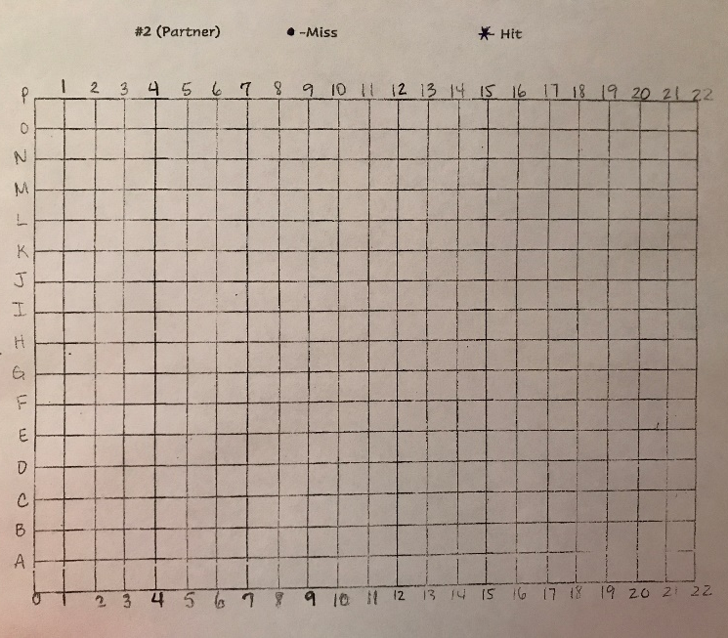
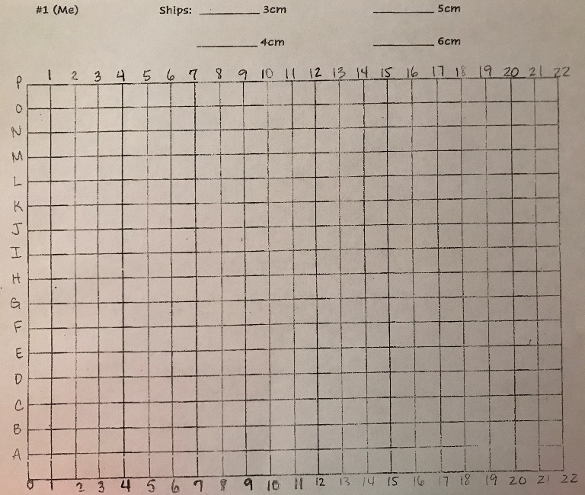
Sheet 1 with your ships. Sheet 2 where you record hits and misses.

