Science Fun: STEM style

Directions: We have all been using so much technology, let us take a break. Choose 3 of the following activities and share with us what you chose. Read through each activity and see what you have in your household, and what sounds the most fun. This should be FUN!!

- Scavenger Bingo-
  - Directions- Go for a walk and mark off each item that you see, use the blank spaces to add in additional items you see. Show us on Teams your Bingo.
Turtle |  | People walking more than 1 dog |  | An Amazon vehicle
Someone riding a bike |  |  | Geese | Someone playing a sport outside
 | People social distancing | Free space
Someone wearing a face mask | Someone cutting the grass | A pond | Someone riding a scooter | Flowers in bloom
X-mas lights or decorations |  | People NOT social distancing that are not family | A squirrel

- Egg Drop: Mars Rover-
  - Directions- GET PARENT PERMISSION FIRST, DO NOT USE ALL OR ANY EGGS WITHOUT PERMISSION.
  - Problem: What can I use in my household to build a structure that will protect my raw egg AKA Mars Rover?
  - Hypothesis: (If, then): __________________________________________________________________________________________________________________________________________________________________________________________________________________
  - Materials- Since we are at home- Use what you have
  - Independent variable- ______________________________________________
  - Dependent variable- ________________________________________________
  - Directions: Using a raw egg, build something around the raw egg that you can drop from a 2nd floor and not have it break. GO OUTSIDE IF POSSIBLE
  - Constraints: The egg MUST be raw in a bag, sealed before the contraption is built around it. The egg must be retrieved without destroying the device. Bonus- make a target and see how it lands on that target.
  - Take a picture of your build and share. If you challenged your family show their experiments as well.
  - Conclusion- (Prove or disprove hypothesis, explain why you were able to do this and provide future plans). ______________________________________________________________________________________________________________________________________________________________________________________________________________________________________________________________________________________________________________________________________________________________
  - Bonus- Did you challenge a family member? If so, see who can land on a target that you made, AND did not break their egg- that person wins the challenge Explain who you challenged and what the winner did to win this challenge. Show us a picture of the winning build.

- Build a Bird House Feeder-
  - Directions- Using household items to create your own eco friendly bird feeder.
  - Materials- Use household items to start the main part (ideas would be cleaned out, empty milk containers, 2L cleaned soda bottles etc.)
  - Carefully using a knife/scissors to cut through the containers to achieve your desired results, GET PARENT PERMISSION FIRST, SAFETY!!
  - See examples, and show us your results.
  - What is a benefit of making a homemade bird feeder, give us 2. ________________________________________________________________________________________________________________________________________________________________________________________________________________________________________________________________________________________
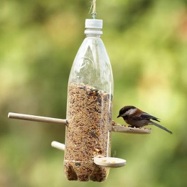
DO NOT USE YOUR KITCHEN UTENSILS WITHOUT PARENT PERMISSION.
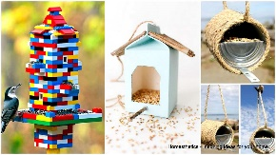
Lego’s are expensive- ASK PERMISSION
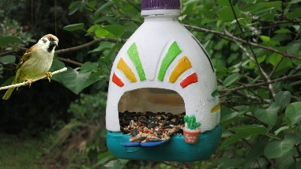
Milk jug or 2 L soda bottle
Be creative!!

- Heavy Paper Challenge
- Problem: How can create a structure that is at least 5 cm off the ground that can hold at least 5 SSR/ AR books?
- Hypothesis: ___________________________________________________________________________________________________________________________________________________________________________________________________________________________
- Materials:
  - 2 pieces of computer/printer paper
  - Scissors
  - 30 cm of tape
  - 5 SSR/AR books
- Procedure:
  - Design a structure (s) that free standing (nothing holding it up) that can be made with the above supplies. Your structure should be able to hold at least 5 SSR/AR books.
  - Share a picture of your structure, hint, think of structures around the world.
- Results: What do you think the total mass of your structure was able to hold? ___________________________________________________________________________________________________________________________________________________________________________________________________________________________
- Conclusion: _____________________________________________________________________________________________________________________________________________________________________________________________________________________________________________________________________________________________________________________________________________________________________________

- Oil Spill Clean up
Directions: Using household items create an oil spill in a controlled environment and determine the best way to clean it up, do not forget about the plants and animals that would be living near a real oil spill.
- Problem: How can I effectively clean up an oil spill that will remove the most amount of oil and have the least damaging effects on the environment?
- Hypothesis: _______________________________________________________________________________________________________________________________________________________________________________________________________________________________________
- Materials
  - 10 ml (convert to standard to measure accurately) of oil (vegetable, oil, canola etc. Use oils found in the kitchen, not garage)
  - Large baking dish
  - 200 ml of water
  - Plants or plastic toys to represent organisms living in the environment.
  - Items you are using to clean up the oil ( you may want to research current oil spill clean up options) List your items you are using. __________________________________________________________________________________________________________________________________________________________________________________________________________________
- Procedure:
  - Get permission from a parent or guardian first.
  - Add the 200 ml of water and 10 ml of oil to your pan.
  - Add your organisms to the pan and mix up to water and oil.
  - Choose your first method to clean the oil and continue until you feel that you have successfully cleaned up all the oil.
- Results: Explain how well your items were in cleaning up the oil and why you chose those items. _________________________________________________________________________________________________________________________________________________________________________________________________________________________________________________________________________________________________________________________________________________________________________________________________
- Follow up questions
  - How could this experiment be used in real life? ________________________________________________________________________________________________________________________________________________________________________________________________________________________________________________________________________________________
  - Are there any negative affects of the clean up items you chose and explain them now? ______________________________________________________________________________________________________________________________________________________________________________________________________________________________________________________________________________________________________________________________________________________________

- Cotton Ball Launcher
Directions: Use household items and see which family member can launch their cotton ball the furthest.
- Problem: Can I build a cotton ball launcher that will send my cotton ball farther than a family member.
- Hypothesis: _______________________________________________________________________________________________________________________________________________________________________________________________________________________________________
- Materials:
  - Short pencil or popsicle stick
  - Thin rubber bands (2)
  - Cardboard tube (2 empty toilet paper tubes or empty paper towel tube cut in half)
  - Packing tape or other strong tape
  - Scissors
  - Cotton balls
  - Single hole punch or something to make holes in the tube.
- Procedure:
a. Use your scissors to cut one of the toilet paper tubes in half lengthwise.
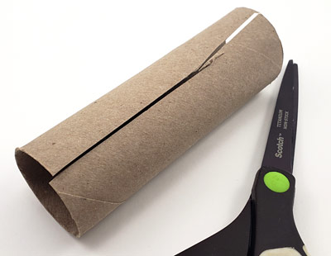
- Squeeze the roll so that it becomes narrower, about half the original diameter, then tape it to hold in place.
- Use your scissors or your hole punch to punch two holes in the skinny tube (if you are using a popsicle stick, use scissors to make narrower holes the same shape as the popsicle stick). Make the holes opposite one another, 2 cm away from the end, so that you can poke your pencil or popsicle stick all the way through the tube.
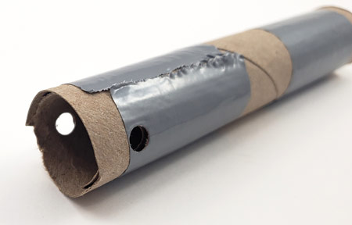
- Carefully push your pencil or popsicle stick through the holes.
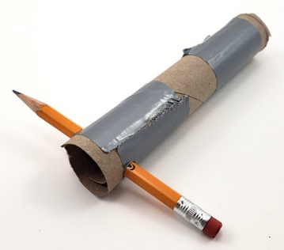
- On your second toilet paper tube, cut two slits into one end of the tube, about 7 mm long and 1.25 cm apart.
- Cut two more slits on the same end of the tube, directly across from the first two.
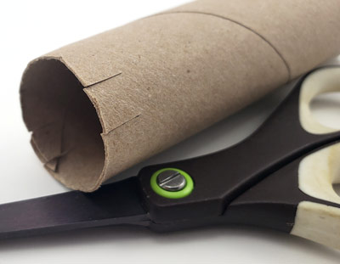
- Carefully loop one rubber band through the slits on one side, so that it hangs from the cardboard piece in the middle. Put a piece of tape over the slits to reinforce the cardboard tab.
- Loop the other rubber band through the slits on the other side of the tube. When you are finished, the tube should have a rubber band hanging from each side.
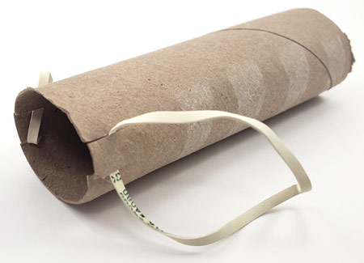
- Holding the rubber band tube so that the rubber bands are at the top, slide the narrower tube into the wider one, with the pencil end at the bottom.
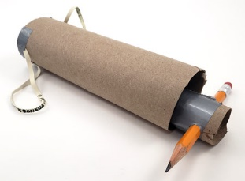
- Carefully loop each rubber band end around the pencil.
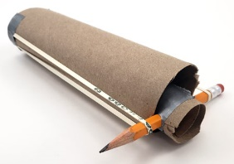
- Hold your launcher so that the pencil is at the bottom. Place a cotton ball on the top, so that it rests inside the narrower tube.
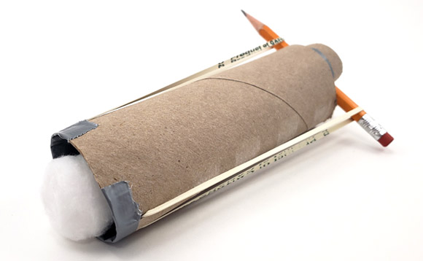
- Hold your launcher slightly horizontally without dropping the cotton ball.
- Pull back on the pencil so that the inner tube extends 6cm out the back of the launcher.
- Carefully aim your cotton ball—away from people!
- Release the pencil and watch your cotton ball fly!
Results: Launch your cotton ball 3 times and record how far they flew. Also, if a family member built one record their data too. (METRIC PLEASE)
- _________________________
- _________________________
- _________________________
- Average: _______________
Conclusion: ____________________________________________________________________________________________________________________________________________________________________________________________________________________________________________________________________________________________________________________________________________

- Airplane Launch
Directions: Use household items to create a launch pad for a paper airplane. Typically, a person throws paper airplanes, but in real life planes propel themselves. Following the guidelines see how far your plane will go.
- Problem: Can I build an airplane launcher that will propel my paper airplane further than when I throw it?
- Hypothesis: _______________________________________________________________________________________________________________________________________________________________________________________________________________________________________
- Materials:
  - Paper
  - Rubber bands
  - Pen or pencil
  - Paper clips
  - Tape or stapler
  - Construction materials to build a paper airplane launcher. You can use whatever materials you have available. Examples include cardboard, building toys such as LEGO® or K'NEX®, or wood.
  - Open area to launch paper airplanes (without wind or strong drafts
- Procedure:
  - Build several paper airplanes to test. Because paper airplanes can get bent or destroyed easily, it is a good idea to build more than one. Ensure that they are all built the same for this activity.
  - Tape or staple a paper clip to the nose of each paper airplane. The outer straight part of the paper clip should point backward parallel to the bottom of the plane, so it can serve as a hook to attach to the rubber band. There will be some pull on the hook, so make sure it is secure.
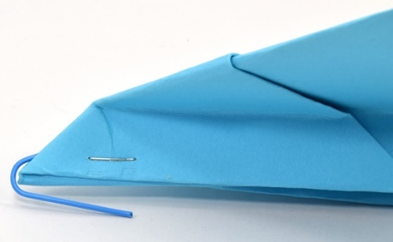
  - Practice throwing your paper airplane using your entire arm. How far can you throw your plane? ______________________________________________________
  - How much do you move your arm when you throw it? ______________________________________________________________________________________________________________________________________________________________________________________________________
  - Now try to throw your airplane only using your wrist. Keep your shoulder and elbow still. How far can you throw the plane now? ______________________________________________________________________________________________________________________________________________________________________________________________________
  - Next try launching your airplane using a very simple "catapult." Hook one end of a rubber band around the end of a pencil (such as around the metal ring by the eraser). Hook the paper clip on the nose of a plane around the other end of the rubber band, and pull it back to stretch the rubber band. Aim the plane forward and release.
  - How far does the plane go now? _____________________________________________________________________________________________
  - How far did you have to stretch the rubber band compared to how far you moved your arm or wrist? ________________________________________________________________________________________
  - Now use the engineering design process to build a more permanent launcher for your airplane. Think about the criteria for your design. You will need to build a device to support the rubber band. It will need to be strong enough that it does not collapse when you pull back on the rubber band. You will also need to make sure the paper airplane does not get caught or snagged on the device when you launch it. Draw a few sketches of your design ideas, and pick one to build.
  - Build a prototype of your design. You might find that things do not fit together like you thought they would, and you need to change your design. That is okay! This picture shows three different designs built with different materials.
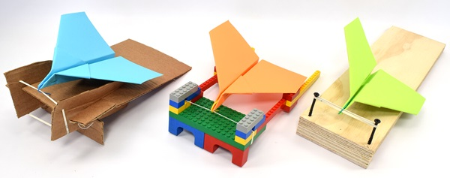
  - Test your airplane launcher. It probably will not work perfectly on the first try. What changes can you make to your design to make it better? _________________________________________________________________________________________________________________________________________________________________________________________________________________________________________________________________________________________________________
  - Keep improving your launcher and testing it again (and, if necessary, again). This process is called iteration, and designers and engineers use it often in their work.
  - How does the plane's flight distance compare to when you threw with your arm or with your wrist? ____________________________________________________________________________________________________________________________________________________________________________________________________________________________________________________________________________________________________________________________________________________________________________________________________________
  - What was the furthest that your plane flew? _____________________________________________________
  - If you and a family member built separate whose went further and why do you think that happened? _________________________________________________________________________________________________________________________________________________________________________________________________________________________________________________________________________________________________________

- Color Taste Test-
  - Problem: Does what I see influence what I taste?
  - Hypothesis: ______________________________________________________________________________________________________________
  - Materials:
- Apple juice, white grape juice, any light colored beverages
- Red, green, and blue food coloring
- Drinking glasses (at least 5
- Water
- Volunteers or just yourself.
  - Prep Work
Note: It is important that your volunteers do not know that there is apple juice or other liquid in each cup! The idea is that your volunteer should expect something different in each cup. Therefore, do not let them see you prepare the drinks ahead of time!
- Pour a small amount of apple juice into each of four drinking glasses.
- Put a drop of red food coloring into one glass, a drop of blue food coloring into the second glass, and a drop of green food coloring into the third glass.
- Swirl the glasses to mix the food coloring in. Add another drop of food coloring if the colors are not dark enough.
- Leave the fourth glass with no food coloring.
- Fill the fifth glass with water.
If you have more drinking glasses, prepare them the same way in sets of five (five for each volunteer). Otherwise, you will need to wash, rinse, and dry them in between volunteers

Procedure
- Set out all five glasses for your first volunteer.
- Ask them to start by drinking some water to cleanse their palate.
- Tell your volunteer to sample the colored drink in each glass one at a time, drinking water in between each one.
- Ask your volunteer which drink was their favorite.
- Now ask your volunteer to close their eyes. Hand them the cups one at a time to taste again, in a random order. Ask them which one is their favorite (based on the initial order—e.g. first cup, second cup...).
- Repeat steps with a new liquid.
Results: Explain what happened ______________________________________________________________________________________________________________________________________________________________________________________________________________________________________________________________________________________________________________________________________________________________________________________________________________________________________________________________________________________________________________________________________________________________________________________________________________________________________________________________________________________________________________________________

Conclusion: _________________________________________________________________________________________________________________________________________________________________________________________________________________________________________________________________________________________________________________________________________________________________________________________________________________________________________________________________________________________________________________________________________________________________________________________________________

- Polar Ice Caps and the Sea Level
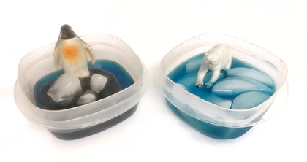
Introduction
Have you ever noticed that if you leave an ice cube out on the kitchen counter and come back to check on it in a while, you find a puddle? The same thing happens to ice in nature — if the temperature gets warm enough, the ice melts. In this science activity, you will explore what happens to sea levels if the ice at the North Pole melts, or if the ice at the South Pole melts .It is an especially important question for the millions of people who enjoy living along the coasts of the world.
- Problem: Does melting ice at either cap contribute to a rise in sea levels?
- Hypothesis: ____________________________________________________________________________________________________________________________________________________________________________________________________________________________________________________________________________________________________________________________________
- Materials:
  - Play-Doh® or modeling clay
  - Measuring cup
  - Butter knife
  - Clear plastic or glass containers, approximately 600 ml in size (2). Smaller or larger containers can be used, if they are both the same size, but you will need to scale up or down the amount of dough you add to the containers. Since you will be marking these containers with a permanent marker, make sure they are containers you are allowed to mark.
  - Colored tape or permanent marker (if you do not mind marking your containers with marker)
  - Tap water
  - Ice cubes

Prep Work
- If you are using containers that are not 600 ml in size, scale up or scale down the amount of dough you use in the activity's procedure.
Procedure
- Put one cup of Play-Doh or modeling clay into one of the clear containers. This container will be a model of the South Pole, with the mound representing the continent of Antarctica. Use a butter knife to scrape around the sides of the measuring cup, if necessary. Make the top of the dough flat and level. Leave some space between the sides of the dough and the wall of the container all around, so that you can add water later.
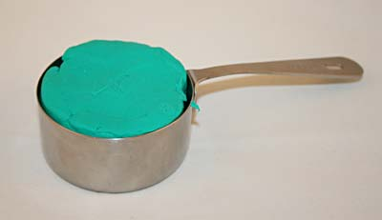
- Take your model of the South Pole and carefully add around ¼ cup of water around the sides of the dough, so that the water level comes up about one-third to half of the way up the dough mound. The water represents the ocean.
- Place two ice cubes on top of the dough, lightly pressing them down into the dough. Immediately mark the water level on the side of the container with the permanent marker or colored tape. The ice cubes represent the southern polar ice sheet in this model of the South Pole.
What do you think will happen as the ice cubes melt?
- Take the second, clear container and fill it about one-third to half full of tap water. The water represents the ocean. Add two ice cubes to the container and immediately mark the water level on the side of the container with colored tape or a permanent marker. This container is a model of the North Pole, where the ice cubes represent the floating northern polar ice cap.
What do you think will happen as the ice cubes melt?

- 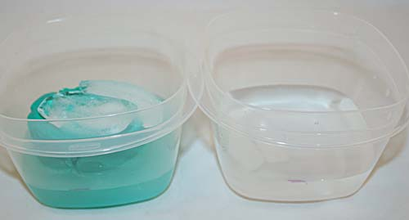
- Allow the ice in your models to melt in a place where they will not be disturbed. Keep an eye on the ice cubes in the South Pole model to make sure they stay balanced on the dough, and that the water from these melted ice cubes can drain off of the dough.
- Once the ice has completely melted, check the water level in each container again
- Follow up- What was the most surprising to you about this activity? ____________________________________________________________________________________________________________________________________________________________________________________________________________________________________________________________________________________________________________________________________________________________________________________________________________________________________________

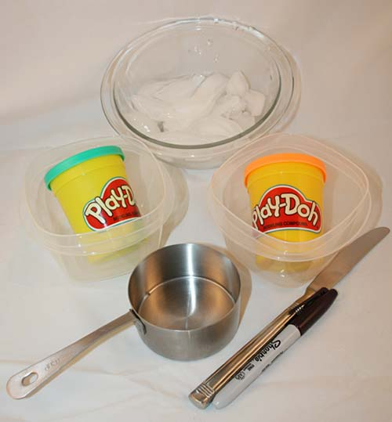

10.Life Skills: GET PARENT PERMISSION BEFORE DOING ANY OF THESE

  - Learn how to do a load of laundry: Sorting, washing, drying and folding.
  - Who helped you?
  - How can this help you in the future?
11.Life Skills:
1. Learn how to make a breakfast item. Cereal and milk does not count. The stove/oven must be used.
a. What did you make? Share a picture ____________________________________________________________________________________________________________________________________________________________________________________
b. Was it good? How would you change it next time? ____________________________________________________________________________________________________________________________________________________________________________________________________________________________________________________________________________________________________________
12. Life Skill:
1. Learn how to cook a “secret” family recipe. Share a picture
2. What did you learn how to make? Will you keep the recipe the same or will you modify it? ______________________________________________________________________________________________________________________________________________________________________________________________________________________________________________________________________________________________________________________________________________________________________________________________________
3. what is one of your favorite family recipes that has been passed down, or created by your family. If none, what do you want to create as a new family traditional recipe? ____________________________________________________________________________________________________________________________________________________________________________________________________________________________________________________________________
13. Life Skill:
1. Prepare a dessert, share a picture.
2. As people prepare to get back to socializing, what dessert is a favorite of yours, or one you have always wanted to make.
3. How did the dessert turn out? Would you change anything in the future when making this dessert? Why or why not? ___________________________________________________________________________________________________________________________________________________________________________________________________

