Remote Learning May 11-15, 2020

Hello everyone! I hope you’re staying healthy and safe in your homes. I realize these days are scary and constantly changing so I’m going to try to make stress-free activities but still cover the standards for chemistry. I’m as bummed out as you with these requirements to stay at home because chemistry is fun and involves so many exciting, active experiments. I’m going to include some experiments that I have done in the classroom for you to try if you have the materials at home. The experiments aren’t not mandatory for you to complete but beneficial to teach the concepts. If you’re overwhelmed or have any questions, please email me directly and I’ll respond within 24 hours. I miss all of you!
It’s time to start the last science book, “Interaction of Matter Book L” chapter 1 and learn about the valence electrons of atoms. It’s time to explore all of the elements in more detail! I have a song for you to listen to https://www.youtube.com/watch?v=rz4Dd1I_fX0ng
- Using a new online textbook at my.hrw.com “Interactions of Matter book L” read pages 3-7 and fill in the blanks of the PowerPoint “Book L section 1 Valence electrons” slides through Teams.
- View PowerPoint “How to Lewis Structure” and practice completing 20 Lewis dot structures available through Teams.
- Create a model of an atom with some type of craft materials (construction paper, pom poms, pipe cleaners, or yarn – be creative) by using the “How Can You Model the Nuclear Atom?” lab sheet through Teams. Take a picture, save it and submit it to Teams.

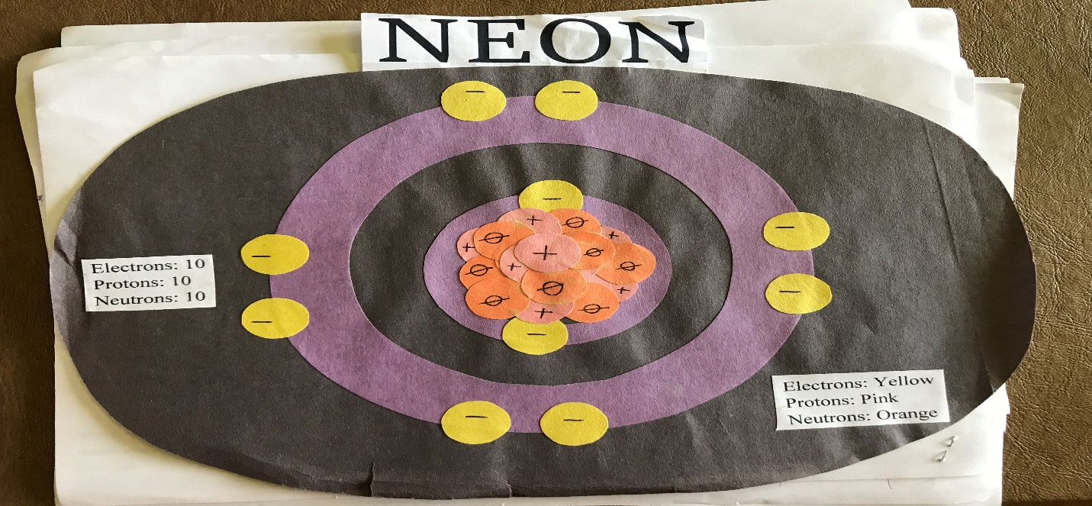

- Complete Element Builder Gizmo at https://www.explorelearning.com/ the student exploration sheet is available in Teams and submit it to Teams.
- Science in the kitchen – Optional based on materials available, try “Law of Conservation of Mass Lab”. (available on my teacher page as download)

Keep working hard and do your best! I have opened Questions and Concerns channel through Teams if you need help or want to touch base with me
Summit Program:
- Complete the assignments #1-4 listed above about Bohr models and the Lewis structure of atoms. .
- Science in the kitchen – Optional based on materials available, try “Law of Conservation of Mass Lab”. (available on my teacher page as download)
- Try the Build an Atom simulation at https://phet.colorado.edu/en/simulation/build-an-atom

