Name: _______________________________________ Date: _______________ Period: _____ Rev. 6/19

Summative Reassessment Form
Please fill out this form to reassess your summative assessment. You are expected to follow the steps outlined here for your opportunity to reassess.

Assessment Title: ______________________________ Class: _____________ Score: _______

Steps to take for the opportunity to reassess:
- The NEWEST score will be recorded in the gradebook, even if the most recent score is lower than the original. Reassessment format may not be the same as the original assessment given.

- Complete this form with student and parent signature. All areas of this form need to be completed in complete sentences with specific details.

- Return all missing/incomplete/LATE assignments attached to this form within 3 days of receiving this form.

- Students must redo the assessment within 5 days during academic behavioral study hall (ABS) from when the assessment is handed back. Students will only receive one day to complete this reassessment.

- NO redo/reassessment will be provided during the last week of a quarter.

- If any of the above steps are not completed, then the students have chosen to forfeit the opportunity to take the reassessment.

***Each reassessment will be considered on a case by case basis using teacher’s discretion***

1. What steps did you take to prepare for the original assessment (studying)?

__________________________________________________________________________________________
2. Why do you believe you earned the score you did? Give three reasons.
________________________________________________________________________________________

__________________________________________________________________________________________

Here are some ideas for study tools for daily preparation:
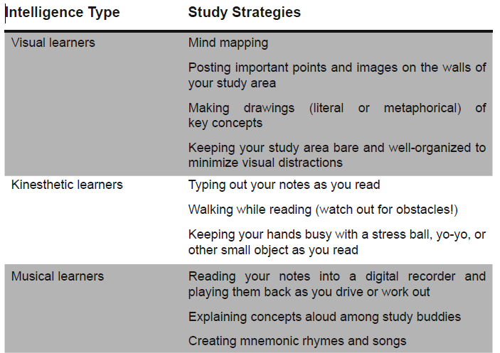
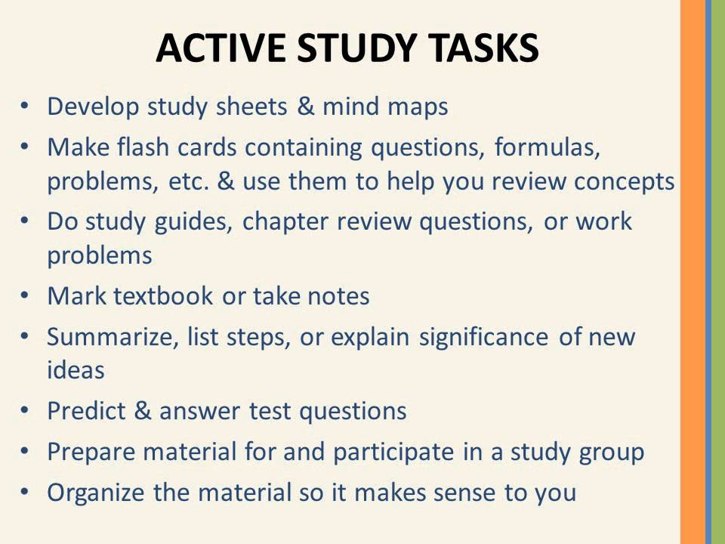
Preparing for a Math Test
- Make a List of Important Concepts/Formulas. Review video lessons, your notes, and make a concise list of important concepts and formulas. Make sure you know these formulas and more importantly how to use them!
- Rework Homework Problems. Do not just read over the homework problems. Actually rework them. Writing down the steps will help you to remember them. Make sure that you try to do the problems without looking at the solutions.
- Rework Book/Notes Examples. Cover up the solutions to book or note examples and try to rework them. When looking for problems from the book don’t forget that most books have a review section at the end of each chapter that usually contains more problems.
- Look for Identifying Characteristics in Problems. While doing your homework you knew which section it came out of. This provided some clues as to the solution process. During an exam you won’t have this to help you. So, while reviewing your homework look for identifying characteristics that will give you clues on how to identify that kind of problem.
- Take a Practice Exam. Find some problems and treat them like practice test. Give yourself a time limit and don’t use your notes or book.

Teacher signature: __________________________________________________ Date:______________

Student signature: __________________________________________________ Date:______________

Parent signature: ________________________________________________ Date: _____________

