Summit Hill School District 161
20100 S. Spruce Drive
Frankfort, Il 60423
815-469-9103

String Orchestra Handbook
2019 – 2020

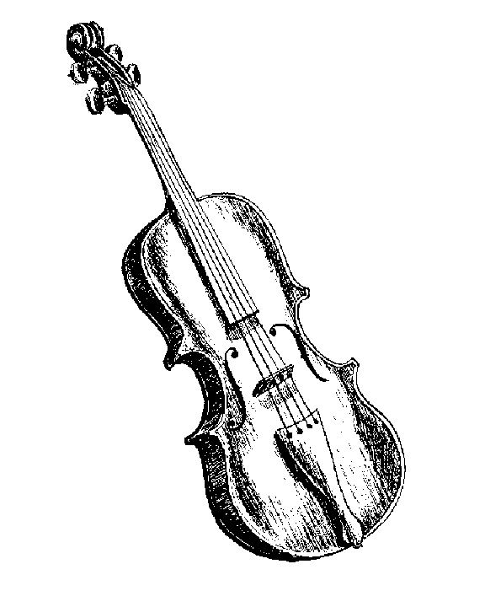

Dear Parents,
Welcome to the String Orchestra program at Summit Hill School District 161! Orchestra is one of the most rewarding and exiting opportunities your student can take advantage of! Music education provides students with a wealth of benefits. In addition to obtaining the musical skills needed to perform, a child learns skills that can be used throughout their life. Team-work, dedication, self-discipline, and responsibility prepare a child for a successful future in any chosen profession. Our orchestra program allows each student to develop all of the above traits as well as experience the beauty and joy of making music!
The following pages of this handbook include all of the information you need for your student to have a successful year in our orchestra. Please do not hesitate to contact me throughout the school year.

Sincerely,

Mrs. Katie Goddard
String Orchestra Director
cgoddard@summithill.org
815-469-4330

String Orchestra Program Philosophy
The philosophy of the string orchestra program is to develop the whole child through instrumental performance education.
Benefits of learning a musical instrument include:
- The ability to read music
- Self-expression
- Creativity
- Concentration
- Problem-solving
- Goal-setting
- Memory skills
- Teamwork
- Poise
- Social skills
- Self-confidence and esteem
- Physical coordination
- Community
- The ability to accept criticism
Family also benefits from musical involvement, including:
- Musical event attendance
- Family music-making
- Performing for, and with, family and friends
- A sense of accomplishment and pride for the entire family

District 161 String Orchestras

Beginning String Orchestra
Members of the Beginning String Orchestra have little or no string instrument playing experience. Upon joining, students have the choice of learning violin, viola, cello, and string bass. Any students grades 5 – 8 are welcome to join Beginning Strings. Beginning Strings rehearsals are on Tuesday and Thursday mornings at 7:00 am (student drop-off at 6:45 am). Rehearsals are held at Summit Hill Jr. High. Fifth and sixth grade students are brought over to Hilda Walker by school bus at the end of rehearsal. The Beginning String Orchestra performs 3 times each year. These performances are the Winter Concert, Winter Strings Extravaganza, and Spring Concert. Please see the calendar page for specific dates/locations/times. The annual district fee is $20.00.

String Ensemble
String Ensemble is the title of our 5 – 8 grade string orchestra. Members of the String Ensemble have 1 or more years of playing experience. String Ensemble rehearses on Wednesday and Friday mornings at 7:00 am (student drop off at 6:45 am). Fifth and sixth grade students are brought over to Hilda Walker by school bus at the end of rehearsal. The String Ensemble has 4 performances each year. These performances are the Fall Concert, Winter Concert, Winter Strings Extravaganza, and the Spring Concert. Please see the calendar page for specific dates/locations/times. The annual district fee is $20.00.

Small Group Lessons:
Junior high members will receive one small group lesson each week with the director. Small group lessons focus on individual advancement of string instrument skills. The curriculum is tailored to each student’s needs, with appropriate age level goals being set for the end of each school year. Students will receive quarterly progress reports.

Additional Performance Opportunities:
I.L.M.E.A.
The District 161 Orchestras are members of the Illinois Music Educators Association (I.L.M.E.A.), District 1. This enables our students to participate in the annual I.L.M.E.A. District Festival. Our advanced students may audition for a seat within the festival, which will be comprised of the strongest students from about seventy area school districts. Auditions are held in late September with a one-day festival in November.

I.G.S.M.A.
The District 161 Orchestras are members of the Illinois Grade School Music Association (I.G.S.M.A.), District VI. This entitles our students to participate in Solo & Ensemble Contest each year. This Contest is optional, and held in February. Students are encouraged to prepare a solo or an ensemble (duet/trio), which is then performed in front of a judge for a rating. Details regarding Solo & Ensemble are communicated in December.

Instruments:
For your convenience, District 161 utilizes Quinlan and Fabish Music Co. for rentals.
Quinlan and Fabish Music Co.
www.qandf.com
6827 High Grove Boulevard
Burr Ridge, Il 60527
(630) 654-4111

A representative from Quinlan and Fabish visits the school(s) weekly (or as needed) to pick up and drop off instruments/supplies. Students are not required to use Quinlan and Fabish. However, an instrument of good quality will allow for students to achieve their best sound. Please be sure that your student’s instrument is from a reputable dealer.

Uniforms:
Beginning String Orchestra Uniform:
- All black dress clothes; black dress socks/shoes
- NO jeans, sweat pants, t-shirts, hoodies, etc.

String Ensemble Uniform:
All members of the String Ensemble will be assigned a uniform. The uniform is on loan for the year; distributed in the fall and collected in the spring.
- Boys will need to purchase a tux shirt for their uniform. Tux shirts will be sized and ordered each fall. Tux shirts purchased will be used every year. Boys will also need all black dress socks (not ankle socks) and all black dress shoes.

- Boys will receive the following:
- Tuxedo Jacket
- Tuxedo Trousers
- Satin Cummerbund
- Bow Tie
- Garment Bag

- Girls will need their own black dress shoes. Girls will receive the following:
- Concert Dress

- Cost/Care:
- Students will sign out their uniform at the beginning of the school year and pay a cleaning fee of $9.00.
- All uniform pieces (except tuxedo shirts) will be collected in the spring. Uniforms will utilize the cleaning fee and be cleaned and stored for the following school year.
- Uniforms should not be altered. If dresses need to be hemmed, please do NOT cut the material.
- In the case of missing or damaged uniform pieces, it is the responsibility of the student to pay for the replacement costs.
- Tuxedo (coat & trousers) $100.25
- Bow Ties $3.25
- Satin Cummerbunds $8.50
- Garment Bag $6.00
- Concert Dress $70.00

Policies:
- All students are expected to attend all rehearsals and performances. Junior high students are expected to attend their weekly small group lessons.
- Unavoidable rehearsal/performance conflicts should be communicated to the director as soon as possible.
- The director will not be responsible for making up lessons skipped by a student or by a student’s absence. Snow days and holidays will be rescheduled when possible.
- Students will be responsible for missed assignments from all missed classes due to lessons.
- Students using a school instrument will be requested to pay a maintenance fee and to sign a contract. Abusive or neglectful damage must be repaired at the student’s expense.
- Students are not to use another’s instrument or music without their permissions. This includes school instruments.
- Students are to come prepared to all rehearsals with their instruments, books, music, and a pencil.

Conduct and Behavior:
A sense of pride in representing Summit Hill should always be exhibited as a member of our school orchestra. All school rules and district policies will apply to rehearsals and out of school trips.

Calendar:
Please mark your family calendar with the following concert performance dates. All concerts begin at 7:00 pm.

- Fall Concert (String Ensemble only)
Thurs., October 17, 2019 @ SHJH (with HW/SH bands)

- Winter Concert (Beginning Strings & String Ensemble)
Tues., December 17, 2019 @ HW (with HW 6th band)

- Winter Strings Extravaganza (String Ensemble only)
Mon., February 10, 2020 @ LW East (with LW Youth Strings, Hickory Creek Strings, and LW East Orchestra)

- Spring Concert (Beginning Strings and String Ensemble)
Tues., May 12, 2020 @ SHJH

- Additional Dates:

- ILMEA Auditions (SHJH is hosting)
Sat., Sept. 28, 2020 @ SHJH

- ILMEA Festival
Sat., November 2, 2019 @ Joliet THS

- Eighth Grade Parent Meeting (all 8th music dept. parents)
Mon., January 27, 2020 @ LW East 6:00 pm

- IGSMA Solo/Ensemble Contest
Sat., February 15, 2020 @ TBA

