**Dear Friends,**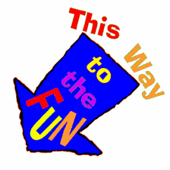

**I wanted to say Hello!**

**Even from far away.**

**We are missing each other a lot,**

**Including all the things we do together!**

**So, let’s change that!!**

**It will be so much FUN!!**

**Whatever you do, I want to come too!**

**Just like the book, Flat Stanley!**

**Anything from building a fort,**

**Maybe cooking in the kitchen.**

**We can ride your bike,**

**Or simply read a good book.**

**Take a picture of ME with YOU!**

**Send the picture to me**

**And write about what we did together.**

**I can’t wait to hear all about it!**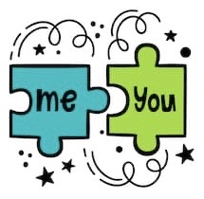

**And your friends will too!**

**I can’t wait to be busy and**

**enjoying time TOGETHER!!**

**Just you and me!**

**Love,**

**Mrs. Rios**

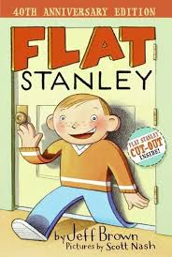**If you don’t know the story about**

**the original Flat Stanley,**

**you can watch the read aloud.**

[**Click Here**](https://www.youtube.com/watch?v=PVsiFx9ZyFo&t=24s) **to go to it.**

**On the next pages you will see**

**some pictures of “ME”**

**Choose any one you want!**

**Print it out, if you can.**

**Cut it out and glue it onto a**

**piece of cardboard so it’s sturdy.**

**If you can’t print one,**

**then just draw your own picture of me!**

**That would be fun too!**

**Then let’s HANG OUT!**

**Take a photo of us together!!**

**Take a picture of your writing about our adventure too! Send the pics to me on Remind messages and I will post them on the stories for all of us to see and enjoy! Have fun!**

**Also, write about our adventure together!**

**Tell me all about what we did!**

**You can do as many as you want! At any time!!**

**HAVE FUN!!**

