Muscular System Study Guide
Walker PE
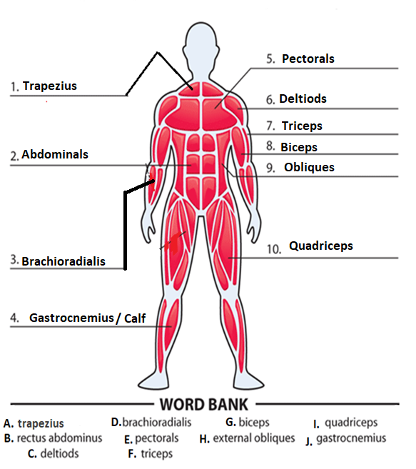
- Smooth Muscles- Which include the muscles of internal organs and blood vessels. These muscles move involuntary.
- Cardiac Muscle- Found only in the heart and are involuntary.
- Skeletal Muscles- Are voluntary and help you move.
Muscular System Study Guide
Walker PE

- Involuntary- Automatically move without you knowing.
- Voluntary- Brain sends message to muscle. You control the movements.
- Flexion- Movement that reduces a joint angle.
- Extension- A movement that increases a joint angle.
- There are 600 muscles in the human body. 