Dear Parents,

We are continuing with our unit on scientific method. We will be forming a hypothesis and identifying with the outcomes of possibilities in a wrapped fun sized M&M packet. Each child will receive their own packet and it will only be touched by them. Please sign if you are allowing your child to eat the candies after the experiment has concluded

____________ - I allow my child to eat the candies after they experiment

____________- I prefer that my child DOES NOT eat the candy

Child’s name:_______________________________________________________________
Parent signature:___________________________________________________________
**** Due back by Monday 9/25

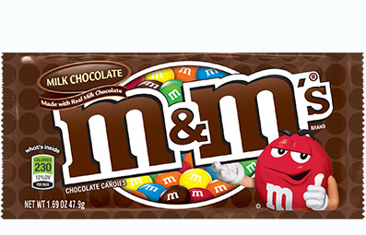

Ingredients Declaration:
MILK CHOCOLATE (SUGAR, CHOCOLATE, SKIM MILK, COCOA BUTTER, LACTOSE, MILKFAT, SOY LECITHIN, SALT, ARTIFICIAL FLAVOR), SUGAR, CORNSTARCH, LESS THAN 1% - CORN SYRUP, DEXTRIN, COLORING (INCLUDES BLUE 1 LAKE, YELLOW 6, RED 40, YELLOW 5, BLUE 1, RED 40 LAKE, BLUE 2 LAKE, YELLOW 6 LAKE, BLUE 2), GUM ACACIA. CONTAINS MILK AND SOY. MAY CONTAIN PEANUTS.

