The email from John Snipes was more for Class link I apologize. Once you get into class link it will display a screen with little icons and names. Find Office 365 and click on it to open.
Once you click on the Office 365 icon it will take you to a screen similar to this

Click on teams you will then see a page with your child teams similar to this… 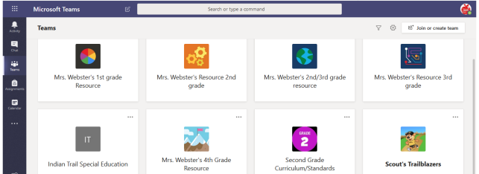 they may only have 1 or 2 teams
Then click on the team with my name. Write a hello so I know you were able to access it. I am able to put in assignments and edit and return to your child and I will try to access this to add games as well.
LET ME KNOW IF I CAN HELP IN ANY WAY

